Moodle2Word Test Question – English template

Test Questions in Microsoft Word for import into Moodle

Boolean question - soccer (TF)
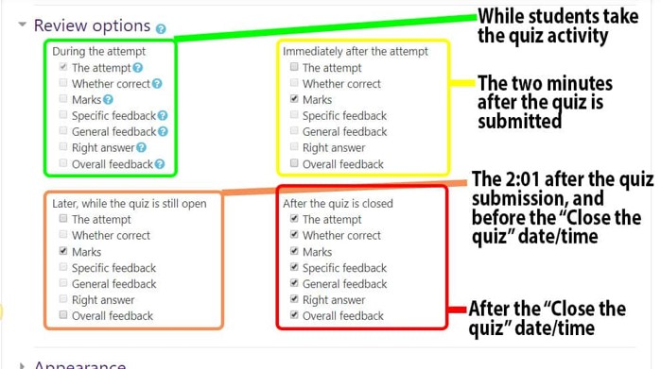  Real Madrid beat Liverpool in the Champions League Final 2018. True or False? |  |  | TF
Default mark: |  |  | 1
 | Answers | Feedback | Grade
 | True |  | 100
 | False |  | 0
 | General feedback:
 | Tags:
Set grade '100' to the correct answer.

